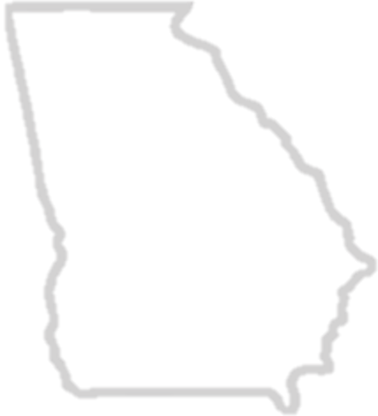
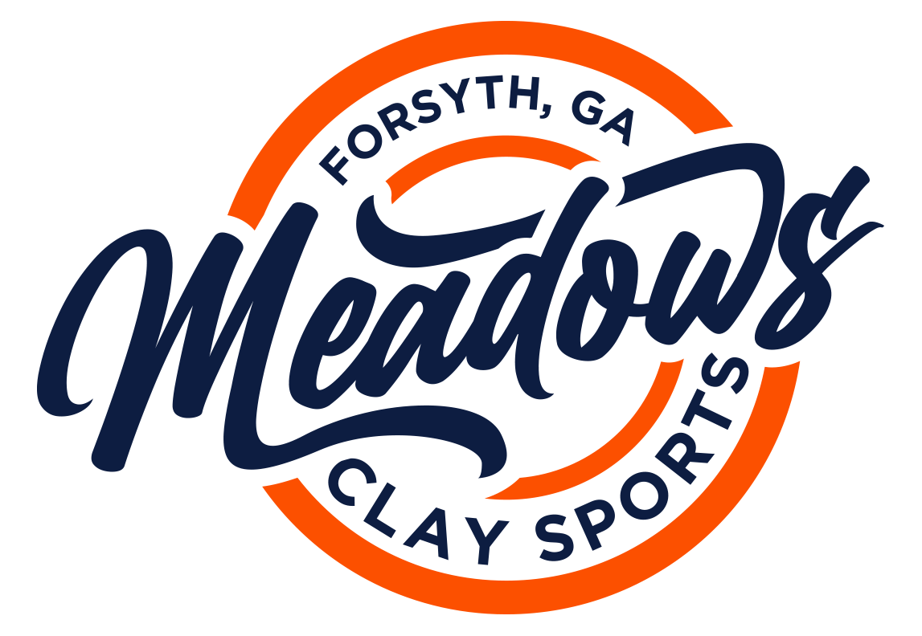
2023 JUNIOR GEORGIA BLAST
Sporting Clays Championship
April 22nd & 23rd, 2023
Meadows Clay Sports – 1064 Rumble Road – Forsyth, Georgia 31029
Phone: (478) 994-9910 - Email: info@meadowsclaysports.com - Website: www.meadowsclaysports.com
Team Name: __________________________________________ Coach Name: ____________________________________________________
School/ Club: _________________________________________ T-Shirt Size: ______________________________________________________
Organization: (check one) ___ SCTP ___ 4-H ___ NRA Phone: __________________________________________________________
___ NSCA ___ Other: ______Address: ________________________________________________________
Coaches Certification: ___ SCTP ___ NRA City: __________________________ State: __________ Zip: ______________
___ Other: ________________Email: ____________________________________________________________
1st Shooter: Name:_____________________________________________________ T-Shirt Size _______ Grade: _______ Age: ______
Address: __________________________________________________ City: ______________ State: _______ Zip: ________
Division: _____ Rookie_____Intermediate _____Jr. Varsity ____Varsity ____Collegiate
Concurrent Division (Ladies ONLY): _____ Rookie_____Intermediate _____Jr. Varsity ____Varsity ____Collegiate
2nd Shooter: Name:_____________________________________________________ T-Shirt Size _______ Grade: _______ Age: ______
Address: __________________________________________________ City: ______________ State: _______ Zip: ________
Division: _____ Rookie_____Intermediate _____Jr. Varsity ____Varsity ____Collegiate
Concurrent Division (Ladies ONLY): _____ Rookie_____Intermediate _____Jr. Varsity ____Varsity ____Collegiate
3rd Shooter: Name:_____________________________________________________ T-Shirt Size _______ Grade: _______ Age: ______
Address: __________________________________________________ City: ______________ State: _______ Zip: ________
Division: _____ Rookie_____Intermediate _____Jr. Varsity ____Varsity ____Collegiate
Concurrent Division (Ladies ONLY): _____ Rookie_____Intermediate _____Jr. Varsity ____Varsity ____Collegiate
Event Rotations Cost Total
Main Event: Saturday ___9:00 AM ___12NOON ___3:00 PM $400.00 3-Person Team $_______________
Super Sporting: European Rotation $45.00 x ____________ $_______________
5-Stand Event: ___Saturday ___ Sunday $45.00 x ____________ $_______________
Cart Rental: ___Saturday ___ Sunday ______ Days x $60.00 = $_______________
Total Due $ _______________
I hereby certify that I have read and understand the OFFICIAL RULES and REGULATIONS for this event. I understand that failure to comply with the rules and guidelines may result in penalties and/ or possible disqualification from any or all events.

Coach’s Signature: _____________________________________________________ Date: __________________________
2023 JUNIOR GEORGIA BLAST
Sporting Clays Championship
April 22nd & 23rd, 2023

Reminders

-April 16th, 2023 @ 6:00 PM EST we will not be taking any more submissions for teams. If you are interested in this sporting clays event, please register your team within a reasonable time period. Rotation times fill up quickly, please keep this in mind.
-April 20th, 2023 @ 6:00 PM EST is the last day coaches will be able to make any squad changes for your overall team. Coaches, if you have a child who is sick, injured, or unable to make the event, please let the Meadows Staff know within 24 hrs so we can make the necessary changes.
-Coaches, please fill out the spreadsheet that is attached to this memo sheet so we can make registration easier for you.
Helping us with this, helps us give you a perfect event for your kids to enjoy.

Awards
We will give the awards as follows….

Main Event
Team 1st-3rd
Individual Division 1st-3rd
Ladies Division 1st-3rd

Super Sporting
Individual Division 1st-3rd
Ladies Division 1st-3rd

5-Stand
Individual Division 1st-3rd
Ladies Division 1st-3rd

